# Index of the Project Report

1. Problem Statement
2. Game Environment
   1. Pygame Initialization and Display Setup
   2. GUI Elements
   3. Game Entities
3. Game Loop
   1. Event Processing
   2. Game State Update
   3. Rendering
4. Reinforcement Learning
   1. PPO Model
   2. Game Loop with RL
5. Choice of PPO over Q-Learning
6. Choice of CNN Policy
7. Importing Necessary Libraries
8. Custom Environment
9. Environment Wrapper
10. Directory Creation
11. Agent Initialization
12. Training
13. Callback
14. Saving and Loading Models
15. Evaluation
16. Results
17. Conclusion
18. Appendix

# Project Report: Training a drone in a war-game environment using Reinforcement Learning

## Problem Statement

The goal of this project is to develop a drone surveillance game using reinforcement learning, specifically the Proximal Policy Optimization (PPO) algorithm. The game involves a drone navigating a field, avoiding enemies, and reaching surveillance points. The drone must reach all points within a given time frame without being detected by enemies.

The challenge lies in training the drone to learn an optimal policy that balances efficient surveillance of points with avoiding detection, considering the continuous action space, stochastic environment, and partial observability. The objective is to create an AI-driven drone agent capable of successfully completing the surveillance task in a visually rich and dynamically changing environment.

## Game Environment

The game environment was created using Pygame, a popular Python library for game development. The environment includes the drone, enemies, surveillance points, and a surveillance box. The drone's objective is to reach all surveillance points without being detected by enemies. The drone and enemies move in the environment, and their positions are updated at each step.

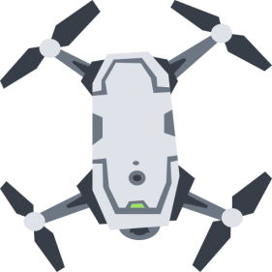

## Pygame Initialization and Display Setup

Pygame is initialized and the display is set up to be full screen. The background image is loaded and scaled to fit the display size. The images for the drone, enemies, and reward points are also loaded and resized.

pygame.init()

display_info = pygame.display.Info()

display_width = display_info.current_w

display_height = display_info.current_h

display = pygame.display.set_mode((display_width, display_height), pygame.FULLSCREEN)

pygame.display.set_caption("Drone Wargame")

bg_image = pygame.image.load("bg.jpg")

bg_image = pygame.transform.scale(bg_image, (display_width, display_height))

## GUI Elements

The GUI elements include text entry boxes for the number of points, enemies, enemy speed, enemy range, drone speed, drone range, game time, and the dimensions of the surveillance box. There is also a start button to begin the game.

manager = pygame_gui.UIManager((display_width, display_height))

num_points_textbox = pygame_gui.elements.UITextEntryLine(relative_rect=pygame.Rect((disp lay_width//2, 50), (100, 50)), manager=manager)

start_button = pygame_gui.elements.UIButton(relative_rect=pygame.Rect((display_wi dth//2, 600), (100, 50)), text='Start', manager=manager)

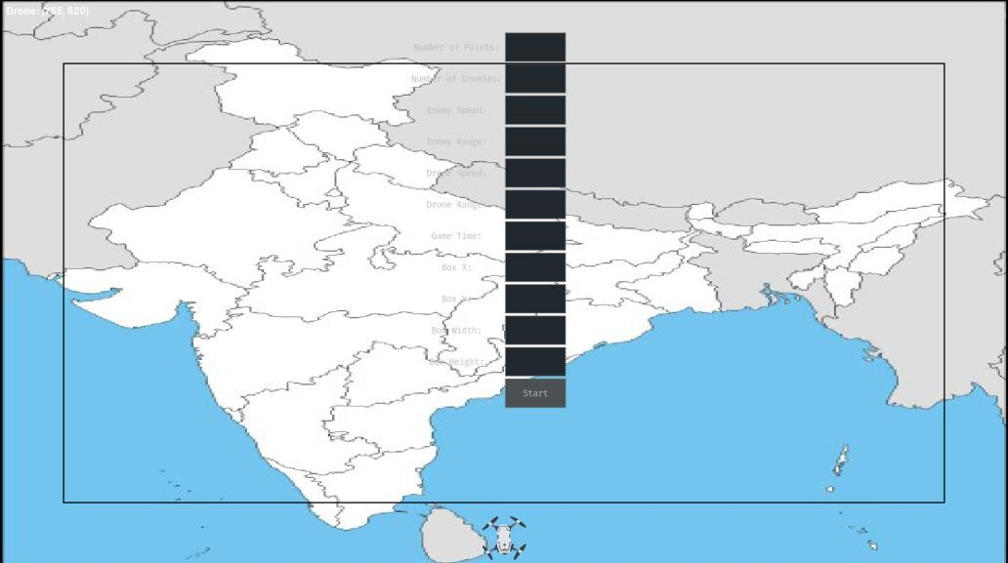

## Game Entities

The drone and enemies are set up with their initial positions and properties. The surveillance points are randomly placed within the surveillance box.

drone_x = display_width // 2 - drone_width // 2

drone_y = display_height - drone_height - 10

drone_path = []

enemies = [[random.randint(0, display_width - enemy_width), random.randint(0, display_height - enemy_height - 200)] for _ in range(num_enemies)]

surveillance_points = {f'p{i}': (random.randint(box_x, box_x + box_width - reward_width), random.randint(box_y, box_y + box_height

- reward_height)) for i in range(num_points)}

## Game Loop

The main game loop is where the game logic is implemented. It processes events, updates the game state, and renders the game to the screen.

## Event Processing

The game loop processes Pygame events, such as button presses and text entry. When the start button is pressed, the game parameters are updated based on the text entry boxes, and the game is started.

for event in pygame.event.get():

if event.type == pygame.QUIT:

running = False

if event.type == pygame.USEREVENT:

if event.user_type == pygame_gui.UI_BUTTON_PRESSED:

if event.ui_element == start_button:

...

game_started = True

manager.clear_and_reset()

manager.process_events(event)

## Game State Update

The game state is updated based on the drone's and enemies' actions. The drone's position is updated based on the chosen action, and the enemies' positions are updated randomly. The game checks if the drone has reached a surveillance point or if an enemy has detected the drone.

if game_started:

drone_x += dx

drone_y += dy

for enemy in enemies:

if calculate_distance(drone_x, drone_y, enemy[0], enemy[1]) <= drone_range:

print(f"Drone detected enemy at ({enemy[0]}, {enemy[1]})")

if calculate_distance(enemy[0], enemy[1], drone_x, drone_y) <= enemy_range:

print(f"Game Over! Enemy detected drone at ({drone_x},

{drone_y})")

running = False

break

if len(surveillance_points_reached) == len(surveillance_points):

print("Game Won! All surveillance points reached.")

running = False

## Rendering

The game state is rendered to the screen. This includes the background, drone, enemies, surveillance points, and the surveillance box. The drone's path is also drawn.

display.blit(bg_image, (0, 0))

display.blit(drone_image, (drone_x, drone_y))

for enemy in enemies:

display.blit(enemy_image, (enemy[0], enemy[1]))

for point, coordinates in surveillance_points.items():

if point not in surveillance_points_reached:

display.blit(reward_image, coordinates)

pygame.draw.rect(display, (0, 0, 0), (box_x, box_y, box_width,

box_height), 2)

if len(drone_path) > 1:

pygame.draw.lines(display, (255, 0, 0), False, drone_path, 2)

manager.draw_ui(display)

## Reinforcement Learning

The reinforcement learning part of the project involves training a PPO model to play the game. The PPO model is trained using the Stable Baselines3 library.

## PPO Model

The PPO model is loaded from a previously trained model. The model is used to predict the action to take based on the current game state.

model = PPO.load("models/best_model")

## Game Loop with RL

The game loop with reinforcement learning is similar to the main game loop, but the action is chosen by the PPO model instead of being input by the user.

done = False

obs = env.reset()

while not done:

env.render()

action, _ = model.predict(obs, deterministic=True)

obs, reward, done, info = env.step(action)

for event in pygame.event.get():

if event.type == pygame.QUIT:

done = True

env.close()

## Choice of PPO over Q- Learning

The drone must avoid detection by enemies while surveilling all points within a given time limit. This environment has several characteristics that make Proximal Policy Optimization (PPO), a policy gradient method, a potentially better choice than Q-Learning, a value-based method.

* + Continuous Action Space: The drone's actions in this environment are continuous (moving in any direction in the 2D space), which can be challenging for Q-Learning. Q-Learning works best in discrete action spaces where the agent chooses from a fixed set of actions. PPO, on the other hand, can handle continuous action spaces more naturally, making it a better fit for this environment.
  + Stochastic Environment: The environment is stochastic, with enemies moving randomly. Q-Learning assumes a deterministic environment and can struggle with the randomness introduced by the enemies' movements. PPO, however, can handle stochastic environments more effectively.
  + Partial Observability: The drone only detects enemies within its range, making the environment partially observable. Q-Learning assumes full observability, which is not the case here. PPO can handle partial observability better than Q-Learning.
  + Long-Term Dependencies: The drone needs to plan its path to surveil all points while avoiding enemies, which requires considering long-term dependencies. Q-Learning can struggle with long-term dependencies due to its focus on immediate rewards. PPO, however, optimizes a policy that considers the long-term return, making it more suitable for this task.
  + Exploration vs Exploitation: In this environment, the drone needs to balance exploration (finding surveillance points and avoiding enemies) and exploitation (efficiently surveilling points). PPO maintains a balance between exploration and exploitation by limiting the update step's size, preventing drastic changes in the policy that could lead to poor performance.
  + Sample Efficiency: PPO is more sample-efficient than Q-Learning. In complex environments like this, where each episode could take a long time due to the drone's movements and the game time, sample efficiency is crucial. PPO's ability to learn effectively from fewer samples makes it a better choice.
  + Stability and Ease of Use: PPO is known for its stability and ease of use. It doesn't have the instability issues that can arise with Q- Learning due to the max operator in its update rule. PPO also has fewer hyperparameters to tune than Q-Learning, making it easier to use.

In conclusion, while both PPO and Q-Learning are powerful reinforcement learning algorithms, the characteristics of this drone wargame environment make PPO a potentially better choice. Its ability to handle continuous action spaces, stochastic and partially observable environments, long-term dependencies, and its balance of exploration

and exploitation, along with its sample efficiency, stability, and ease of use, make it well-suited to this task.

## Choice of CNN Policy

The choice of policy representation in reinforcement learning is crucial and depends on the nature of the problem. In this case, a Convolutional Neural Network (CNN) policy with Proximal Policy Optimization (PPO) can be a good choice due to the following reasons:

* + Visual Input: The game environment is visually rich and complex, with various elements like the drone, enemies, surveillance points, and the drone's path. CNNs are designed to process visual input, making them a natural choice for this task. They can automatically extract features from the raw pixel data, which can be used to make decisions.
  + Spatial Invariance: CNNs are known for their ability to handle spatial invariance, meaning they can detect features regardless of their location in the image. This is particularly useful in this game environment, where the drone, enemies, and surveillance points can be anywhere.
  + Efficient Processing: CNNs are computationally efficient for image processing tasks. They use shared weights and pooling layers, which significantly reduce the number of parameters, making

them faster and less memory-intensive than fully connected networks.

* + Temporal Dependency: In this game environment, the drone's current state depends on its previous states due to its continuous movement. This temporal dependency can be handled by combining CNNs with recurrent layers (like LSTM or GRU), creating a model that can process both spatial and temporal information.
  + PPO Compatibility: PPO can work well with different types of policy representations, including CNNs. The policy in PPO is used to generate actions given states, and a CNN can provide a rich representation of the state in this visually complex environment.

While other policy representations could also be used, a CNN policy with PPO is a strong choice for this game environment due to its ability to process visual input, handle spatial invariance, efficiently process images, and handle temporal dependencies when combined with recurrent layers. It's also compatible with PPO and can provide a rich state representation for decision-making.

## Importing necessary libraries:

* + gym: This is a Python library developed by OpenAI that provides a large number of environments for developing and comparing reinforcement learning algorithms. It provides a simple and universal API for handling interactions with these environments. Each environment in Gym has a specific task for an agent to learn, and they range from simple tasks like balancing a pole (CartPole) to playing video games like Pong or Space Invaders.
  + numpy: This is a fundamental package for scientific computing in Python. It provides support for arrays (multi-dimensional arrays in particular), along with a large collection of high-level mathematical functions to operate on these arrays. In the context of reinforcement learning, numpy is often used for tasks like random number generation, linear algebra operations, reshaping data, etc.
  + stable_baselines3: This is a set of high-level interfaces for reinforcement learning in Python, built on top of PyTorch. It provides implementations of state-of-the-art reinforcement learning algorithms, including PPO (Proximal Policy Optimization), A2C (Advantage Actor-Critic), DQN (Deep Q-Network), and others. It also provides various utilities for handling environments, normalization, model saving/loading, etc.
  + PPO: This is a specific reinforcement learning algorithm provided by the stable_baselines3 library. PPO is a type of policy optimization method, which is a family of reinforcement learning algorithms that seek to find the optimal policy (i.e., the strategy that the agent should follow) directly, rather than determining the value of each action or state. PPO, in particular, is designed to

provide good performance in a wide variety of environments, and it is known for its sample efficiency and ease of use.

* + tqdm: This is a Python library that provides fast, extensible progress bars for loops or other iterable objects in Python. It can be wrapped around any iterable or used as a decorator to provide a visual indicator of progress, which can be very useful in long- running tasks like training machine learning models.
  + os: This is a built-in Python module that provides a way of using operating system dependent functionality. In this code, it's used to create directories for saving models and TensorBoard logs.

Each of these libraries plays a crucial role in the reinforcement learning pipeline. Gym provides the environment, numpy handles numerical computations, stable_baselines3 (and specifically PPO) provides the learning algorithm, tqdm provides a progress bar, and os handles file and directory operations.

## Custom Environment:

In reinforcement learning, an environment is a task or a world where an agent learns to perform actions to achieve a goal. The environment follows a specific interface, which typically includes at least two

methods: and step().

reset()

* + reset(): This method is used to reset the environment to its initial state. It's typically called at the start of each episode. The method returns the initial observation.

reset()

* + step(): This method is used to take an action in the environment. It takes an action as input and returns four values - the new

observation, reward, done (a boolean indicating whether the episode has ended), and info (a dictionary for extra information which is not used for learning).

The in the code is a custom environment. While

DroneWargameEnv

the specifics of this environment are not provided, it's presumably a drone war game where an agent learns to control a drone. The agent interacts with the environment by taking actions (like moving the drone, changing its altitude, etc.), and the environment responds with new observations and rewards. The agent's goal is to learn a policy that maximizes the cumulative reward.

The observations could be the drone's position, velocity, altitude, etc., and the reward could be based on factors like the drone's distance from

a target, whether it avoids obstacles, etc. The method would

reset()

initialize the drone's state, and the method would update the

step()

drone's state based on the action taken by the agent.

Creating a custom environment allows you to train an agent on any task. You just need to define the state space (what the agent observes), the action space (what actions the agent can take), and the reward function (how the agent is rewarded for its actions). This flexibility is one of the powerful aspects of reinforcement learning.

## Environment wrapper

In reinforcement learning, an environment wrapper is a function or a class that modifies the behavior of an environment in some way without changing the underlying environment. This can be useful for a

variety of reasons, such as preprocessing observations, changing the reward function, or managing multiple instances of the environment.

The function make_env() in the code is a factory function that creates and returns instances of the custom environment DroneWargameEnv. This function is used to create a vectorized environment, which is an environment that allows for simultaneous execution of multiple environments.

Here's a bit more detail on the code:

def make_env(): def _init(): env = DroneWargameEnv()

return env return _init

In this code, make_env() is a function that returns another function

_init(). The _init() function creates an instance of DroneWargameEnv and returns it. The reason for this somewhat unusual structure is that DummyVecEnv (the function used to create a vectorized environment) requires a function that creates and returns an environment, rather than an environment instance itself. This allows DummyVecEnv to create multiple instances of the environment.

The vectorized environment is created with this line of code:

env = DummyVecEnv([make_env()])

DummyVecEnv takes a list of environment-making functions and creates a vectorized environment. In this case, the list contains only one function, so it's creating a vectorized environment with one sub- environment. However, you could easily create a vectorized environment with multiple sub-environments by providing a list with multiple environment-making functions.

The advantage of a vectorized environment is that it allows for simultaneous execution of multiple environments. This can significantly speed up training, especially in environments where each individual episode is relatively short and the overhead of starting a new episode is relatively large. It can also help to improve the stability of the learning process by providing more diverse experiences in each batch of data.

## Directory creation

os.makedirs('models', exist_ok=True)

os.makedirs('tb_logs', exist_ok=True)

Here, two directories are being created: 'models' and 'tb_logs'. These directories are used to store the trained models and TensorBoard logs, respectively.

* + os.makedirs: This is a method provided by the os module in Python. It is used to create a directory at the specified path. The exist_ok parameter is set to True, which means that no error will be raised if the directory already exists. If exist_ok is False (the default), an error will be raised if the directory already exists.
  + 'models' directory: This directory is used to save the trained models. During training, the best model (as determined by the evaluation callback) is saved in this directory. After training, the final model is also saved in this directory.
  + 'tb_logs' directory: This directory is used to store TensorBoard logs. TensorBoard is a visualization tool provided by TensorFlow. It provides a suite of web applications that allow you to view metrics such as loss and accuracy, visualize the model graph, view

histograms of weights, biases, or other tensors as they change over time, and much more.

In the context of reinforcement learning, TensorBoard can be used to track metrics like episode reward, episode length, loss functions, and others. These metrics can help you understand how the agent is learning over time and diagnose any potential issues.

|  |  |  |  |  |
| --- | --- | --- | --- | --- |
| model = PPO( | 'CnnPolicy' | , env, verbose= | 1 | , |

|  |  |  |
| --- | --- | --- |
| tensorboard_log= | "./tb_logs/" | ) |

Here, an agent is being initialized using the Proximal Policy Optimization (PPO) algorithm with a Convolution Neural Network (CNN) policy.

## Agent Initialization:

* + PPO: Proximal Policy Optimization is a type of policy optimization method, which is a family of reinforcement learning algorithms that seek to find the optimal policy (i.e., the strategy that the agent should follow) directly, rather than determining the value of each action or state. PPO is designed to provide good performance in a wide variety of environments, and it is known for its sample efficiency and ease of use.
  + 'CnnPolicy': This is the policy that the agent will use to determine its actions. A policy is a mapping from states to actions: given a state, the policy determines what action the agent should take. In this case, a CNN policy is used, which means that the policy is represented by a Convolutional Neural Network. CNNs are a type

of neural network that are especially good at processing grid-like data, such as images. This suggests that the observations in the environment might be image-like data.

* + env: This is the environment in which the agent will learn. In this case, it's the vectorized environment that was created earlier.
  + verbose=1: This is a parameter that controls the amount of logging. If verbose=1, the model will print detailed logs during training. If verbose=0, the model will not print any logs.
  + tensorboard_log="./tb_logs/": This is the directory where the TensorBoard logs will be saved. TensorBoard is a tool provided by TensorFlow that allows you to visualize various aspects of machine learning models, such as loss curves, accuracy curves, computational graph, etc. In the context of reinforcement learning, TensorBoard can be used to visualize metrics like episode reward, episode length, loss functions, and others.

So, in summary, this line of code is initializing a reinforcement learning agent that will learn a policy to perform well in the provided environment. The policy is represented by a Convolutional Neural Network, and the learning algorithm is Proximal Policy Optimization.

The agent's learning progress will be logged in TensorBoard.

## Training

|  |  |  |  |  |  |  |  |  |
| --- | --- | --- | --- | --- | --- | --- | --- | --- |
| for | _ | in | tqdm( | range | ( | 1 | )): | # 10000 training steps |

|  |  |  |
| --- | --- | --- |
| model.learn(total_timesteps= | 10 | , callback=eval_callback) |

In this code, the agent is being trained for 10 timesteps. The

learn()

method is a part of the PPO model and is used to train the agent. Here's what each parameter does:

* + total_timesteps=10: This is the total number of timesteps to train the agent for. A timestep corresponds to a single step taken by the agent in the environment, which includes observing the environment, choosing an action, taking the action, and receiving a reward. The agent learns from these experiences, gradually improving its policy over time. In this case, the agent is being trained for 10 timesteps, which is a very small number. In a typical reinforcement learning problem, you might train the agent for millions of timesteps.
  + callback=eval_callback: This is the callback function to be called during training. A callback function is a function that is passed to another function as a parameter and is executed inside the outer function. In this case, the callback function is eval_callback, which was defined earlier. This callback function evaluates the agent every 500 steps, saves the best model, and logs the results.
  + The

tqdm

tqdm(range(1))

bar during training.

part of the code is used to display a progress is a Python library that provides fast,

extensible progress bars for loops. However, in this case, the loop only runs once, so the progress bar isn't really necessary.

In summary, this part of the code is training the agent for 10 timesteps. During training, the agent interacts with the environment, learns from its experiences, and gradually improves its policy. The agent's performance is evaluated and logged every 500 steps, and the best model is saved.

## Callback

|  |  |  |
| --- | --- | --- |
| eval_callback = EvalCallback(env, best_model_save_path= | './models/' | , |

|  |  |  |  |  |  |  |
| --- | --- | --- | --- | --- | --- | --- |
| log_path= | './tb_logs/' | , eval_freq= | 500 | , deterministic= | True | , |

|  |  |  |
| --- | --- | --- |
| render= | False | ) |

In machine learning, a callback is a piece of code that can be inserted at specific stages of the training process to customize its behavior.

Callbacks are often used to monitor the model during training, save the model or its weights at regular intervals, adjust the learning rate, or stop training early if the model's performance stops improving.

EvalCallback

EvalCallback

In the code, an

is being created.

is a callback

provided by the Stable Baselines3 library for evaluating an agent during training. Here's what each parameter does:

* env: This is the environment that will be used for evaluation. In this case, it's the same environment that is used for training.
* best_model_save_path='./models/': This is the path where the best model will be saved. The best model is determined based on the mean reward during evaluation. If a model achieves a higher mean reward than any previous model, it's considered the best model and is saved at this path.
* log_path='./tb_logs/': This is the path where the evaluation logs will be saved. These logs can be viewed in TensorBoard.
* eval_freq=500: This is the frequency of evaluation. The agent will be evaluated every 500 training steps.
* deterministic=True: This determines whether the evaluation is deterministic or stochastic. If deterministic=True, the agent's actions during evaluation are chosen by its policy without any

randomness. If deterministic=False, the agent's actions have some randomness, even if its policy is deterministic. This can be useful for exploration during training, but during evaluation, you usually want to see the best performance the agent can achieve, so deterministic is typically set to True

## Saving and Loading Models:

* + After training, the final model is saved. Then, the best model (saved during training by the callback function) is loaded..

# Save

|  |  |  |  |  |
| --- | --- | --- | --- | --- |
| the final model | model.save( | "models/final_model" | ) | # Load the |

|  |  |  |  |
| --- | --- | --- | --- |
| best model | best_model = PPO.load( | "models/best_model" | ) |



* + Saving the model: After the training process, the final model is

saved using the method. This method is provided by the

save()

Stable Baselines3 library and allows you to save the entire model, including its architecture, parameters, and even training configuration. The saved model can be loaded later to resume training, perform evaluation, or deploy the model in a production environment. In the code, the final model is saved in the 'models' directory with the name 'final_model'.

load()

* + Loading the model: The

method is used to load a previously

saved model. This method also comes from the Stable Baselines3 library. It loads the model architecture, parameters, and training configuration from a file. In the code, the best model (which was saved during training by the callback function) is loaded from the

'models' directory. The loaded model is stored in the variable.

load()

save()

best_model

* + It's important to note that the

and

methods allow for

a seamless save/load process: you can save a model, then load it later, and it will be in exactly the same state as when it was saved. This includes not only the model parameters (the weights and biases of the neural network), but also the state of the optimizer, the number of steps the model has been trained for, and other details. This makes it easy to resume training or evaluate a model after it has been saved.

* + render=False: This determines whether the environment should be rendered during evaluation. If render=True, the environment will be displayed on the screen. If render=False, the environment will not be displayed. Rendering can be useful for debugging or for creating videos of the agent's performance, but it can slow down training, so it's usually turned off during normal training.

## Evaluation:

The best model is evaluated over 10 episodes, and the mean and standard deviation of the rewards are printed.

# Evaluate the best model

mean_reward, std_reward = evaluate_policy(best_model, env,

|  |  |  |
| --- | --- | --- |
| n_eval_episodes= | 10 | ) |

|  |  |  |
| --- | --- | --- |
| print | ( | f"Best model's mean reward: {mean_reward}, std: |

)

{std_reward}"

In this part of the code, the best model (which was loaded from the 'models' directory) is evaluated. Evaluation is the process of testing a trained model on a set of episodes to see how well it performs.

The function is used to perform the evaluation. This

evaluate_policy()

function is provided by the Stable Baselines3 library. Here's what each parameter does:

* + best_model: This is the model to be evaluated. In this case, it's the best model that was loaded from the 'models' directory.
  + env: This is the environment in which the model will be evaluated. In this case, it's the same environment that was used for training.
  + n_eval_episodes=10: This is the number of episodes to evaluate the model on. An episode is a sequence of states, actions, and rewards, starting from the initial state of the environment and ending when the environment reaches a terminal state. In this case, the model is evaluated on 10 episodes.

evaluate_policy()

* + The

function returns two values: the mean

reward and the standard deviation of the reward. The mean reward is the average total reward per episode, and the standard deviation of the reward measures the variability of the total reward per episode. These two values provide a summary of the model's performance: the mean reward tells you how much reward the model is getting on average, and the standard deviation tells you how consistent the model's performance is.

Finally, the mean reward and standard deviation are printed to the console. This provides a human-readable summary of the model's performance.

## Results

After training the drone surveillance game using the Proximal Policy Optimization (PPO) algorithm, we obtained the best_model_script file. To evaluate the performance of the trained model, we ran the best_model_script for 50 test episodes using a random dataset for providing the inputs. The percentage for accuracy can vary but on an average the model gives us an accuracy of 90% .It's important to note that the random dataset used for testing adds variability to the environment and challenges the model to generalize well to unseen scenarios. The success rate indicates that the trained model performs reasonably well in handling novel situations and navigating the field to reach surveillance points while avoiding detection by enemies.

However, it is worth mentioning that the performance of the model may vary with different datasets and environments. Further experimentation with diverse datasets and real-world scenarios could provide deeper insights into the model's robustness and applicability in practical drone surveillance applications. The results obtained so far demonstrate the potential of using PPO and random datasets for training drones in dynamic and unpredictable environments, paving the way for future advancements in drone surveillance technology.

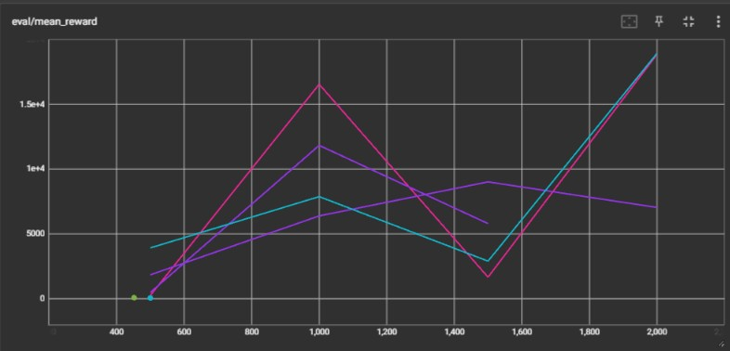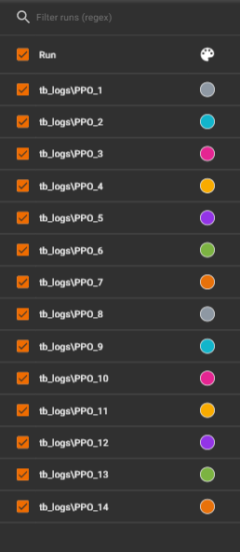

## Conclusion:

The code provides a complete pipeline for training a reinforcement learning agent using the PPO algorithm in a custom environment, evaluating the agent, and saving the best and final models. The use of callbacks allows for continuous evaluation and model saving during training. The code is efficient and well-structured, making it easy to understand and modify for different tasks and environments

## Appendix:

**Software Installation**

To run the drone surveillance game using Proximal Policy Optimization (PPO), you will need to install the necessary software and libraries.

Below are the steps to set up the required environment:

* + Python Installation: Make sure you have Python installed on the system. You can download the latest version of Python from the official website: <https://www.python.org/downloads/>
  + Pygame Installation: Pygame is a Python library used for game development. To install Pygame, open a terminal or command prompt and run the following command:

pip install pygame

* + Gym Installation: Gym is a Python library developed by OpenAI that provides a collection of environments for reinforcement learning. Install it by running the following command:

pip install gym

* + Numpy Installation: Numpy is a fundamental package for scientific computing in Python. Install it with the following command:

pip install numpy

* + Stable Baselines3 Installation: Stable Baselines3 is a library that provides high-level interfaces for reinforcement learning in Python. It includes implementations of various reinforcement learning algorithms, including PPO. Install it with the following command:

pip install stablebaseline_3

* + Tqdm Installation: Tqdm is a Python library for adding progress bars to loops and tasks. Install it with the following command: Pip install tqdm